
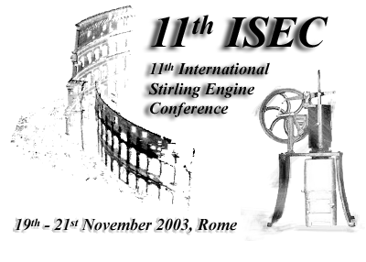
Department of
Mechanical and Aeronautical Engineering
University of Rome “La Sapienza”

11th International Stirling Engine Conference
- 11th ISEC -

Preliminary Programme

“Aule del Chiostro”
Faculty of Engineering
University of Rome “La Sapienza”

Rome, 19th– 21st November 2003
http://dma.ing.uniroma1.it/isec2003
Wednesday, November 19th, 2003

16:00 Conference Registration

17:00 Visit to the Church of S. Pietro in Vincoli and to the Mosè di Michelangelo

18:00 Opening Ceremony

19:00 Welcome Cocktail

Thursday, November 20th, 2003

9:00 Opening General Session
Invited speaker
Prof. I. Kolin, Zagreb University, Zagreb, Croatia
(Issue to be defined)

Thermodynamics and Systems Design
Chair……………………..

11:30 Coffee Break

12:00 Technical Session
Promising Applications of Stirling Engines
Chair……………………..

13:30 Lunch

14:30 Parallel Events
Poster Session | Meeting of the  International Stirling Engine Council

16:30 Coffee Break

17:00 Technical Session
Design and Construction of Components
Chair……………………..

Friday, November 21st, 2003

9:00 Technical Session
Operational and Environmental Aspects and Problems
Chair……………………..

11:00 Coffee Break

11:30 Technical Session
Innovative Solutions and Developments
Chair……………………..

13:30 Lunch

14:30 Industrial and Commercial Perspectives of Stirling Machines

16:30 Coffee Break

17:00 General Session
The Present and the Future Perspectives of Stirling Machines: Policies to be Implemented
Chair……………………..

18:30 Closing Ceremony

